

Phoenix Taekwon-Do Gisborne proudly present The Midlands Regional Camp 22nd – 24th Feb 08
Mission Impossible - The Battle of the Kaimai’s,

To be held at Gisborne Health Camp, Childers Road, Gisborne.

Name___________________________ D.O.B._______________ Age________

Address_________________________________________________________________

Contact Numbers H____________ M____________ Emergency________________

e-mail address___________________________________

School/ Club________________________________ Instructor________________

Medical Conditions we need to be aware of_____________________________________

Dietary Restrictions we need to be aware of____________________________________

Camp fee $50.Cheque enclosed $__________________
Please make cheques payable to Phoenix Taekwon-Do Gisborne.

After completing this form please forward it to
Midlands Camp 2008
76 Oak Street
Gisborne The deadline for this application is 31st January 08
Declaration of Liability.
I declare and acknowledge that I willing participate in camp activities at my own risk. I have disclosed any physical restriction, disability
or predisposition to sickness or injury that may be aggravated or adversely affected as a result of my participation so organizers can take
steps to minimize risk to myself.
I shall take full responsibility for any loss or damage to my person or my property that may arise directly or indirectly from my participation
at this camp. I will not seek to penalize, prosecute or claim compensation from the organizers, sponsers instructors, lecturers or participants
for any injury loss or damage. The information on this form will be used by the camp organizers to complete an attendance register,
I acknowledge my right of access to this information.

Your signature__________________________ Date___________

Signature of parent or guardian (if under 18) _________________________ Date_____________

You need to bring
- Dobok & Belt
- Mouth guard
- Sparring gear (if you have it)
- Swim wear
- Running gear & shoes
- Several changes of clothes
- Wet weather gear (as if you will need it…)
- Pillow & sleeping bag
- 2 Towels
- toiletries
- sun block & hat
- Drink bottle
- Any medication (to be handed in to our first aid person upon arrival)
- A happy disposition & good sense of fun

*A delicious plate of home baking * One plate per family

Registration. Any Questions or queries please contact
Please arrive at camp between 4 & 7 pm on Friday night Cyrena Bennett,
unless prior arraignments have been made. 76 Oak Street Gisborne
Please note. A light supper will be provided on Friday 06 8671435 H
evening. Participants are to ensure they have had their 027 4432560 M
evening meal prior to arriving at camp. All other meals,
snacks and drinks are provided.

Conclusion.
Camp ends on Sunday at 11 am. Parents / guardians can arrive
from 10.30am onwards to collect children.
Use link to find us You can view this map here.
Thanks for using Smaps.
http://www.smaps.co.nz
Or map below

Print me out
Gisborne via Makaraka SH2 from Opotiki. Turn left at Makaraka junction,.You will pass the Showgrounds on your RH side.Follow sign for airport and you will be on Chalmers Road. The camp is signposted.

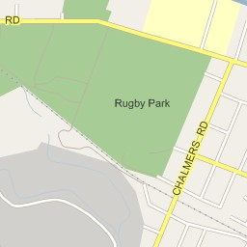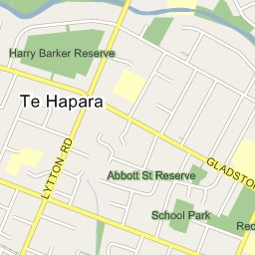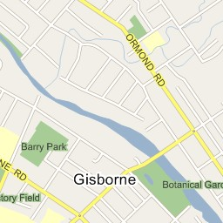
Gisborne Health Camp
