

BLACK BELT GRADING - Kapiti Coast
SATURDAY 24th & SUNDAY 25th May, 2008

INFORMATION DOCUMENT

Organisers:

Ian Leitch, 2nd Dan
Andrew Craig, 3rd Gup

Grading Venue:

Paraparaumu Memorial Hall
Cnr. Tutanekai & Aorangi Streets
Paraparaumu
Kapiti Coast

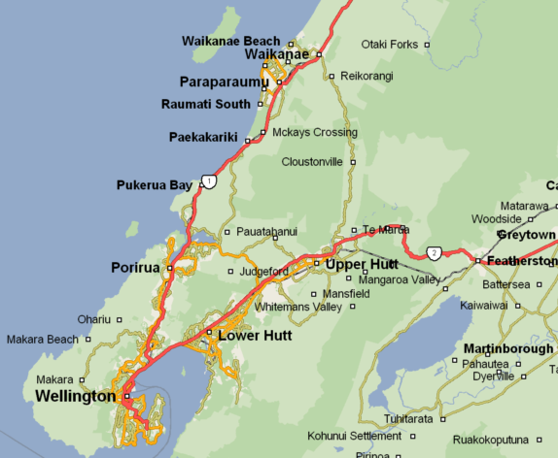

Grading Location

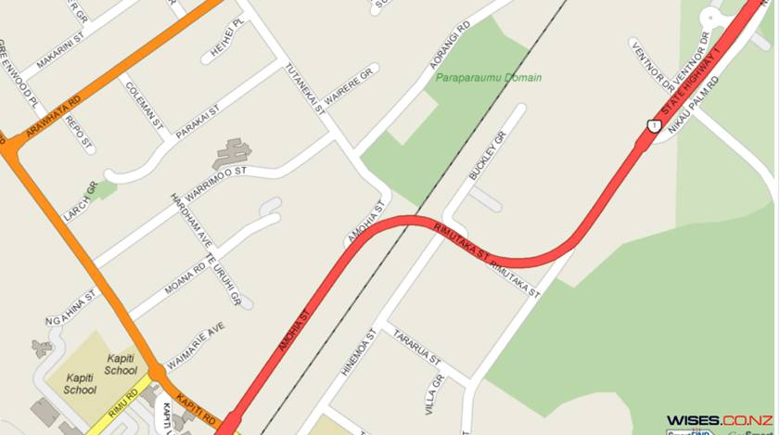
Grading Venue

Grading Examiners:

Mr. Mahesh Bhana, 6th Dan
Mr. James Rimmer, 6th Dan

Organiser Contact Details :

Mr. Andrew Craig  Organiser | Mobile: 021 403-579  Email: andrew@mesh.co.nz
Mr. Ian Leitch  Organiser | Mobile: 021 263-3920  Email: instructor@kctkd.com
Mr. Nick Lourantos  WLG Regional Director | Mobile: 021 439-482  Email: wellington@itfnz.org.nz

Assistance / Questions:

If you have any special requirements for the grading or would like any assistance with such things as accommodation please contact either of the organisers.

Car Parking:

Car Parking is available at the venue. The car park will be monitored to ensure all vehicles are secure.

Grading Programme:

Saturday 24th May 2008

7:30am Gym Opens
8:00am Students arrive
8:30am Form Up (Brief talk from Organisers and Warm Up)
9:00am Examiners arrive grading begins

Sunday 25th May 2008

7:30am Gym Opens
8:30am Students arrive and are seated in Exam Room
9:00am Examiners arrive, grading begins

Things to Know & Do:

- Bring pens / pencils for the written exam. Extra paper will be supplied if needed. As this is an exam, please use the toilet before hand

- Once the written & oral exam is completed and the examiners have dismissed you, then you have free time to get yourself prepared for the afternoon session

- Any pieces of equipment / props required should be placed close to the front for easy access, when called up. Mouth guards should also be nearby for easy access

- Ice bags / First aid kits will be available

- Ensure you bring sufficient liquid refreshments to last the entire day

- Bring a towel and appropriate / comfortable running attire and shoes

