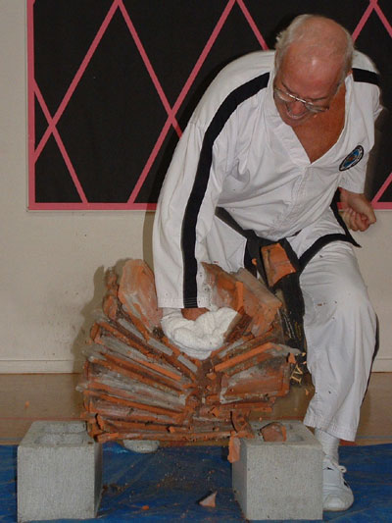
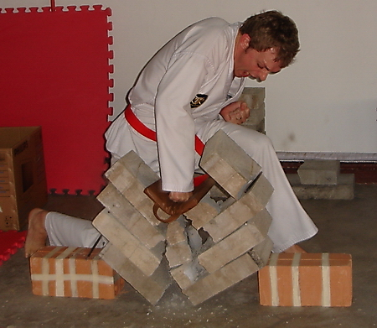
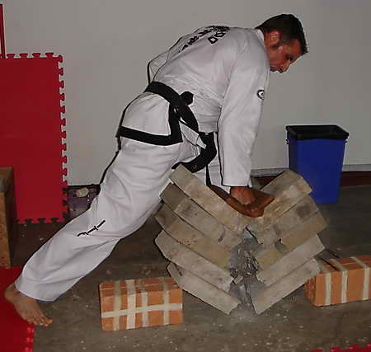
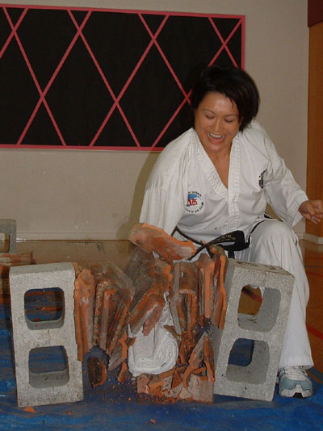
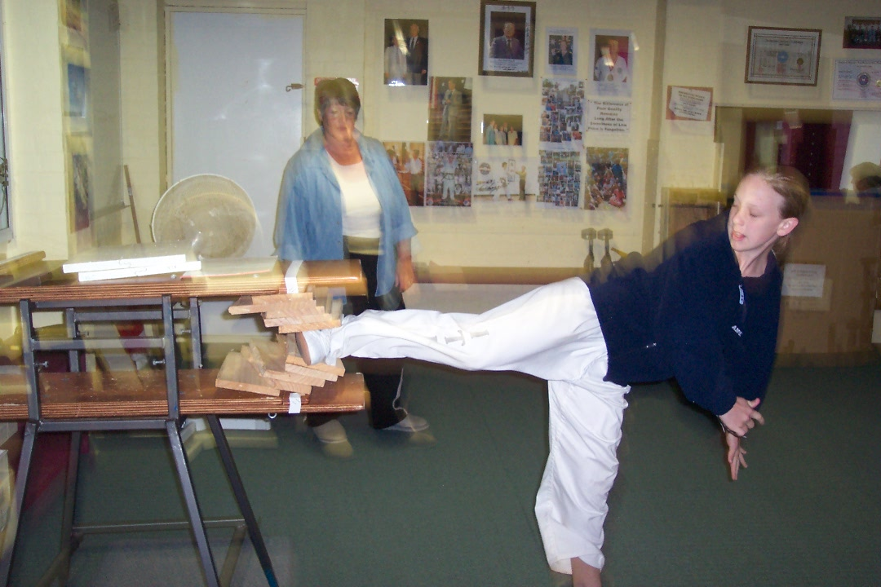
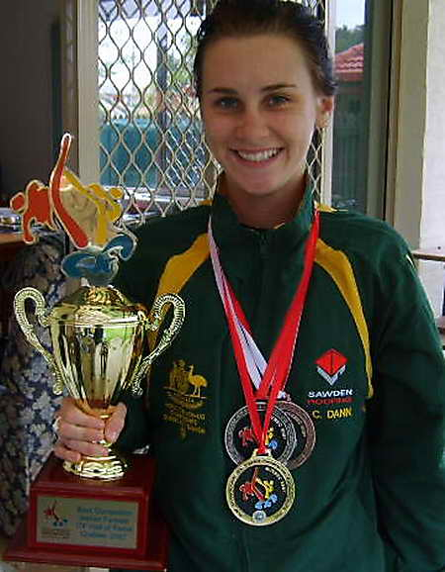


Power Breaking Seminar
Palmerston North
Saturday 16 July 1.00pm - 4.00pm
Learn from World Champion Power Breaking Coaches
Master Rocky (7th Dan) and Mrs Trish Rounthwaite (5th Dan)
Venue to be advised
Green belt and above – 14 yr old and above
$25 individual, $45 family of two, $50 family of three or more
Multiple breaking stations – limited to 20 students
Pre seminar registration required www.rtrtkd or ph 0210323289
(Pay on the day)

