Nationals Newsletter #1.

Hi everyone...
This is the first of a number of newsletters that will be sent out providing updates for the ITKD Nationals to be held in Tauranga this year.
The event will be held at the “Queen Elizabeth Youth Centre” on July 26th & 27th 2014. Organisation of this event is underway and information will be sent out in due course to Regional Team Managers to distribute to competitors.
We are sure our event in Midlands will meet the needs of the participants, officials, supporters, and spectators.
To keep everyone informed we will be producing a frequent newsletter and will be shortly setting up the web page on the ITKD site to ensure that as much information is available as possible. We hope to see you all at this years National Tournament and we will be aiming to make it something very special. We are aiming 350+ competitors.

Master J.Rimmer & C Y-J/The Organising Committee

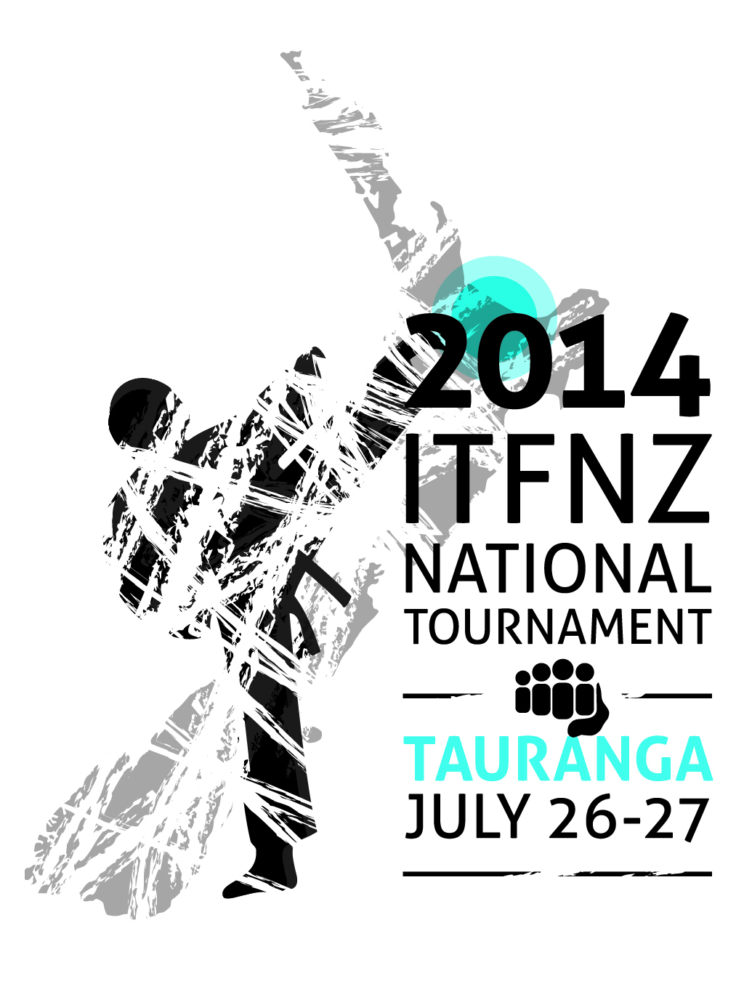

The Logo...
The Logo for this years Nationals Tournament was the creation of Mrs. Katherine Kudo I Dan from BOPTKD Academy and is shown above.

The Sponsors…
TBC

The Venue...
We are very fortunate to have secured a booking for the 2014 Nationals Tournament at the “Queen Elizabeth Youth Centre”, same venue as 2008.
The is big enough to house six rings.
There is a substantial amount of seating for competitors and spectators at the venue and we will be restricting access to the competition floor areas to competitors and officials only. There will be a lunch area on site with a vantage point to continue viewing the tournament whilst eating.
The “Queen Elizabeth Youth Centre” is based close to Tauranga’s CBD, on the stunning Tauranga waterfront.
Just minutes from downtown Tauranga, this venue also has ample parking for cars and buses.

Need a map?…
Go to www.zoomin.co.nz type in “Eleventh Avenue Tauranga”, the venue is right next to Memorial Park. You can print a copy if like.

The Format …

The format for this years event will unfold in due course. Mr. Brown and his crew will fill everyone in further down the track.


Accomodation … here’s your best bet as a group!

Hotel Armitage can offer you the rate of $120 per studio double or studio twin per night. This is based on a maximum of 2 people sharing, on a room only basis. Quote 'Taekwon-Do National Champs' when booking directly with the hotel. This must be done by emailing info@hotelarmitage.co.nz, or calling our reservations team on 07 578 9119. They do have some larger rooms available, but it would be best for teams to contact the hotel directly in order for them to best accommodate you.
They can also offer breakfast and dinner in the hotel restaurant, if required although there are cheaper options downtown. A continental breakfast is $13 per person, and cooked breakfast is $18 per person. Dinner options are variable depending on required menus.
This hotel is right on the doorstep of downtown Tauranga, has a bar, pool table etc. Also room for buses.
If you have any queries then contact the hotel direct on 07 578 9119.

The Dinner…
The 2014 Awards Dinner will be held on the Saturday Night of the tournament at “Daniels In The Park … immediately next door to the tournament venue. The awards dinner will be limited to approximately 110 persons, more to follow. It has always been my aim to give people free time this year to enjoy the city so it is my intention to make the tournament and the Awards Dinner a slick process at the end of a long day and not drag on into the evening.

The Teams…
Once again we anticipate a huge turnout in Tauranga simply as it is close to our largest TKD community in Auckland. ID cards will once again be required for ALL participants and officials and we will be asking team managers for their strict co-operation in this exercise. More to come.

Officials…
There is also a need to ensure that we have enough officials to meet the programme requirements this year as per usual and provide for the spectators a feast of ITF Taekwon-Do in a professional manner … so ALL hands on deck! This may mean delegating others to second students at ringside rather than having officials in this capacity. Remember your contribution credits!
The dress code will be SRTICTLY adhered to as well. Failing this then your first trip into town may well be Hallensteins or Farmers or the No.1 Shoe Warehouse!

Venue Access …
We cannot gain access to the venue until 7.30pm on the Friday night for set-up however we are able to store gear within the premises, have the weigh in, set up the kitchen etc prior so please refrain from swarming the venue and hampering set-up proceedings.

Observations from the past:
NO short sleeved shirts, ALL shirts MUST be White and long sleeved.
Ties MUST be worn at all times.
Shoes MUST be White, no dirty off White or scruffy footwear.
Navy Trousers and Jackets, NOT BLACK.
Shirts MUST be ironed.

Key Contacts…

Tournament Organisers

Master J.Rimmer jw.rimmer@xtra.co.nz

Mrs.Christine Young-Jasberg ce_young@hotmail.com

