International Taekwon-Do Events Management Policy
Version 1.4 Updated 26 October 2011
ShaunTolley – Operations Executive


Table of Contents
1.0 Background 3
2.0 Event Classifications 3
2.1 International Events (Class A) 4
2.2 National Events (Class B) 4
2.3 Regional Events (Class C) 4
2.4 Member or School Events (Class D) 4
2.0 Class (A) Requirements 4
3.0 Class (B) Requirements 5
4.0 Class (C) Requirements 5
5.0 Class (D) Requirements 5
6.0 Financial Reporting Pre and Post Event 5
7.0 Event Partnership and Member Participation Agreement 5
8.0 Member Event Funding 6
9.0 Member information recording, storage and conditions of use 6
10. Supplier and Sponsorship Agreements 6

Background
As events management has become more complex and member involvement continues to increase as national membership numbers expand, there is an increased demand on all events to be project managed to a higher level so as to offer the membership a consistent, safe and enjoyable experience attending International Taekwon-Do events.

The organisational structure of ITKD is as follows and should be consulted in regard to following management, reporting and communication protocol when organising an event Internationally, Nationally at Regional, Club or Member level.

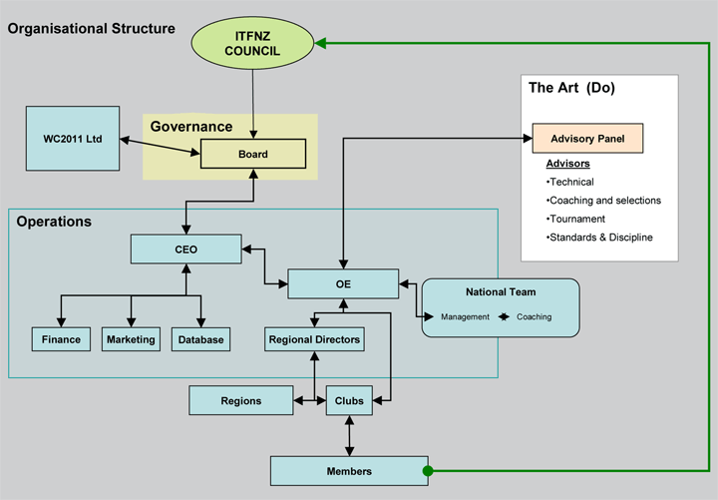

The main role of the Event Managements Policy is to outline the various requirements, responsibilities and standards of service expected for officially sanctioned International Taekwon-Do events.

2.0 Event Classifications
These can be categorised using the following classes. All event classifications require express permission to calendar from the appropriate Advisor, National or International Representative.

International Event (Class A)
National Event (Class B)
Regional Event (Class C)
Member or School Event (Class D)

2.1 International Events (Class A)
    - World Championship (I.T.F.)*
    - World Cup (I.T.F.)*
    - I.T.F. Umpires & Referee Courses*
    - International Camps or Seminars
    - International Instructors Courses **
    - Oceania Tournaments **

*(I.T.F.) Managed primarily through the International Taekwon-Do Federation
**(O.T.F.) Managed primarily through the Oceania Taekwon-Do Federation

2.2 National Events (Class B)
- National Tournaments (Contracted)
- Umpires and Referee Courses
- Instructor Qualification Courses
- Under 18 Tournaments
- National Camps
- National Kids Camps
- Technical Seminars

2.3 Regional Events (Class C)
    - Regional Tournaments
    - Pee-Wee Tournaments
    - Regional Camps or Training Days

2.4 Member or School Events (Class D)
    - Fundraising Seminars
    - Interclub Tournaments
    - Fundraiser Events
    - First Aid Courses

Class (A) Requirements
All “Class (A)” events will be by tender process only and be subject to a contract basis either by the I.T.F, O.T.F or International Taekwon-Do management.

Various contract contents for differing events may be revised and altered in conjunction with the issuer in certain circumstances. This is at the discretion of the issuer only.

Class (B) Requirements
All “Class B” Events will be by tender process only. Expressions of interest to organise Class B events can be initiated via the foundations Website: http://www.itkd.co.nz/events/register/apply-to-host-tournament.php

Some “Class B” National Events require management on a contract basis issued by International Taekwon-Do Management. All other “Class B” events will be subject to the differing advisory group requirements that schedule them.

Class (C) Requirements
All “Class C” Events will be directly overseen and managed by the various regions that schedule them.

Class (D) Requirements
All “Class D” Events are the sole responsibility of the Region, School or Member organising the event.

Financial Reporting Pre and Post Event
All “Class A” and “Class B” event organisers are required to supply a pre-event budget as well as a post event financial report, either to International Taekwon-Do Management, the relevant Advisory heads or their nominated authority.

In the case of a contract managed event, then the contents of any such contract shall take precedence.

Event Partnership and Member Participation Agreement
All “Class A” and other contracted events will be subject to individual contract contents and requirements in regard to partnership and member participation agreements.
All other “Class B” and “Class C” events not expressly managed by Advisory Groups for the purposes of offering qualifications to members will be subject to the following partnership, member participation agreement.
“Class B” 10% of individual, family or group application fee to be returned to the foundation.
“Class C” 5% of individual, family or group application fee to be returned to the foundation.
“Class D” All events under this category are deemed exempt.
Events within these categories that are to receive Foundation funding maybe exempt from the above table under any internal funding agreement contents or previously agreed event management requirements.

Member Event Funding
International Taekwon-Do Foundation member funded events will be by application process only. Funding applications are required to include a pre-event itemised budget showing clearly the amount of funds requested and intended use.

Post event financial reports are required and any profits returned to the foundation up to the amount funded or by prior agreement.

Funding will be at the discretion of the Operations Executive and or C.E.O and maybe subject to availability, conditions of use or negotiation of event requirements and management standards.

Member information recording, storage and conditions of use
Any information gathered, stored or recorded both, electronically or physically containing International Taekwon-Do members, names, addresses, weights, ages or contact details shall be kept secure for the duration of the event and be destroyed immediately upon the completion of the event that it was compiled for.

All “Class A”, “Class B” or “Class C” Events with the exception of Pee-Wee Tournaments must use the official International Taekwon-Do online tournament student registration system or input the results into the online system within one month of the events completion.

If the online system is not used and the Operations team are required to manually check competitor’s member registration then the following administration fees will be applied.

$60.00 per 100 participants or part thereof

Any or all information recorded containing members private or personal information must be used only for the purpose it was expressly compiled for and may never be forwarded, sold or transferred to any second party for any reason.

This is not only policy but covered by New Zealand law and any failure to adhere to these rules may result in criminal proceedings.

10. Supplier and Sponsorship Agreements
Supplier and sponsor agreements for all “Class A” or Contracted events will be subject to individual contracted agreements.
All other supplier or sponsor agreements and their contracted conditions for “Class B” and “Class C” events must obtain express prior acceptance from either the Operations Executive or International Taekwon-Do C.E.O.
No supplier or sponsor agreements can be initiated, offered, implied or accepted before being signed off by International Taekwon-Do management.
International Taekwon-Do has an express event wear supplier agreement for the National Tournament. Any event specific merchandise sold or offered to members or public must be provided by the approved supplier. Failure to adhere to the event merchandise agreement may lead to a complete recall or removal of stock at the tournament organising committees cost.
The event merchandise agreement for event wear can also be adopted by any other organising committee of officially sanctioned iTKD events. This will be subject to normal market competition.

